LAB EXPERIMENT RECORD

SET 23: EMPLOYEE PERFORMANCE ANALYSIS

Department | AIDS
Course Code / Course Name | DSA0601 / Data Handling and Visualization
Experiment | Data Visualization using R
Name | M.Teja kumar
Register Number | 192424308
Date | 15 OCTOBER 2026
Day | Thursday

Aim
To analyze employee performance using a department distribution bar chart, a performance line chart, an interactive dashboard, and a data table in R and Shiny.

Dataset: Monthly Sales

Employee ID | Department | Years of Service | Performance Score
1 | Sales | 5 | 85
2 | HR | 3 | 92
3 | Marketing | 7 | 78
4 | Sales | 4 | 90
5 | HR | 2 | 76

PROGRAM 1: Bar Chart of Employees by Department
To visualize the distribution of employees across different departments using a bar chart.
# # Dataset department <- c(
"Sales", "HR", "Marketing", "Sales", "HR"
)
# Count Employees
department_count <- table(department) # Bar Chart
barplot( department_count,
main = "Employee Distribution by Department", xlab = "Department",
ylab = "Number of Employees",
col = c("lightblue", "lightgreen", "orange")

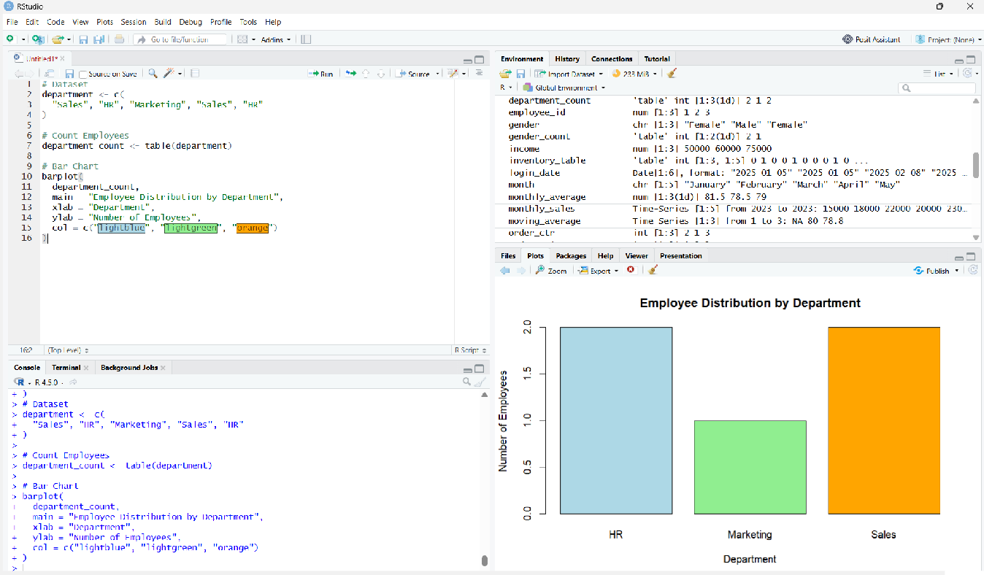
)
Observation: Sales and HR each have two employees, while Marketing has one employee.

PROGRAM 2: Scatter Plot of Advertising Budget vs Monthly Sales
T o visualize employee performance scores using a line chart. # Sample Dataset
month <- c("January", "February", "March", "April", "May") advertising <- c(5000, 6000, 7000, 8000, 9000)
sales <- c(15000, 18000, 22000, 20000, 23000)
# Scatter Plot plot(
advertising, sales,
main = "Advertising Budget vs Monthly Sales", xlab = "Advertising Budget ($)",
ylab = "Monthly Sales ($)", pch = 19,
col = "red"
)

text(
advertising, sales,
labels = month, pos = 3
))

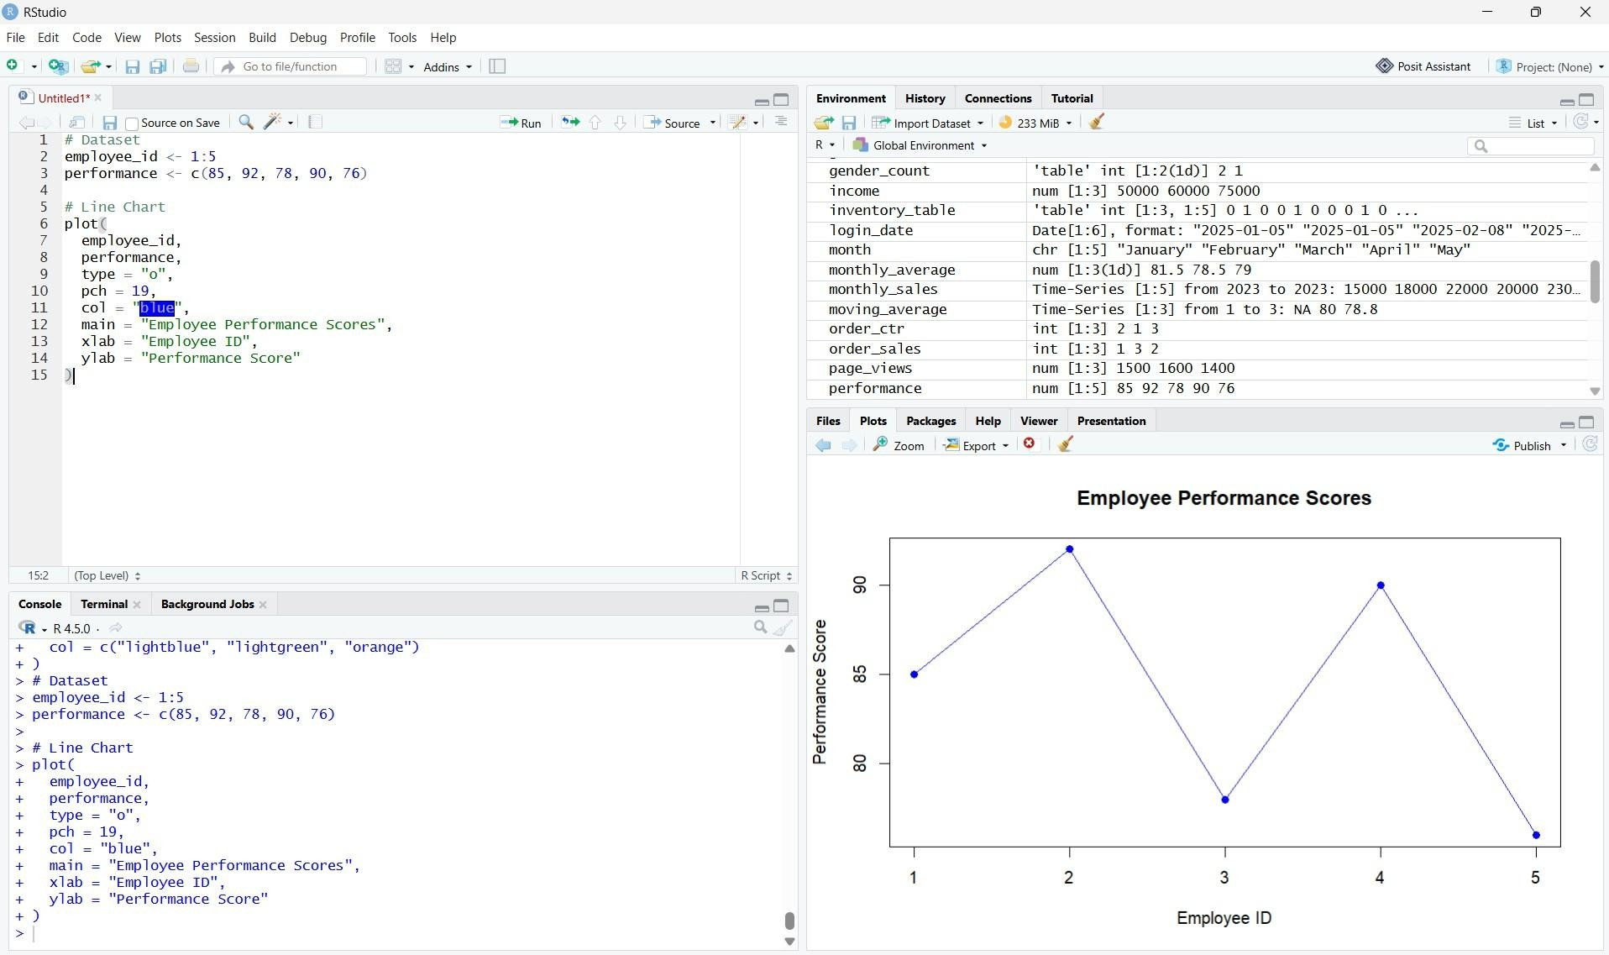
Observation: Employee 2 has the highest performance score of 92, while Employee 5 has the lowest score of 76.

PROGRAM 3: Interactive Monthly Sales Dashboard
To create an interactive dashboard combining a department distribution bar chart and a scatter plot of years of service versus performance scores.
library(shiny)

employee_id <- 1:5
department <- c("Sales", "HR", "Marketing", "Sales", "HR") years <- c(5, 3, 7, 4, 2)
performance <- c(85, 92, 78, 90, 76)

employee_data <- data.frame( Employee_ID = employee_id, Department = department, Years_of_Service = years, Performance_Score = performance
)

ui <- fluidPage(
titlePanel("Employee Performance Dashboard"),

tabsetPanel(
tabPanel("Department Distribution", plotOutput("bar")), tabPanel("Service vs Performance", plotOutput("scatter")), tabPanel("Employee Data", tableOutput("table"))
)
)

output$table <- renderTable({ employee_data
})
}

shinyApp(ui = ui, server = server)shinyApp(ui = ui, server = server))

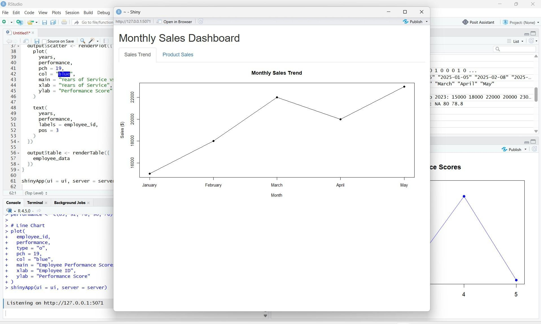
Insight: The dashboard displays department distribution and the relationship between years of service and performance scores. The employee table provides the corresponding details.

PROGRAM 4: Employee Performance Table
To display employee performance data in a structured table with appropriate column labels.
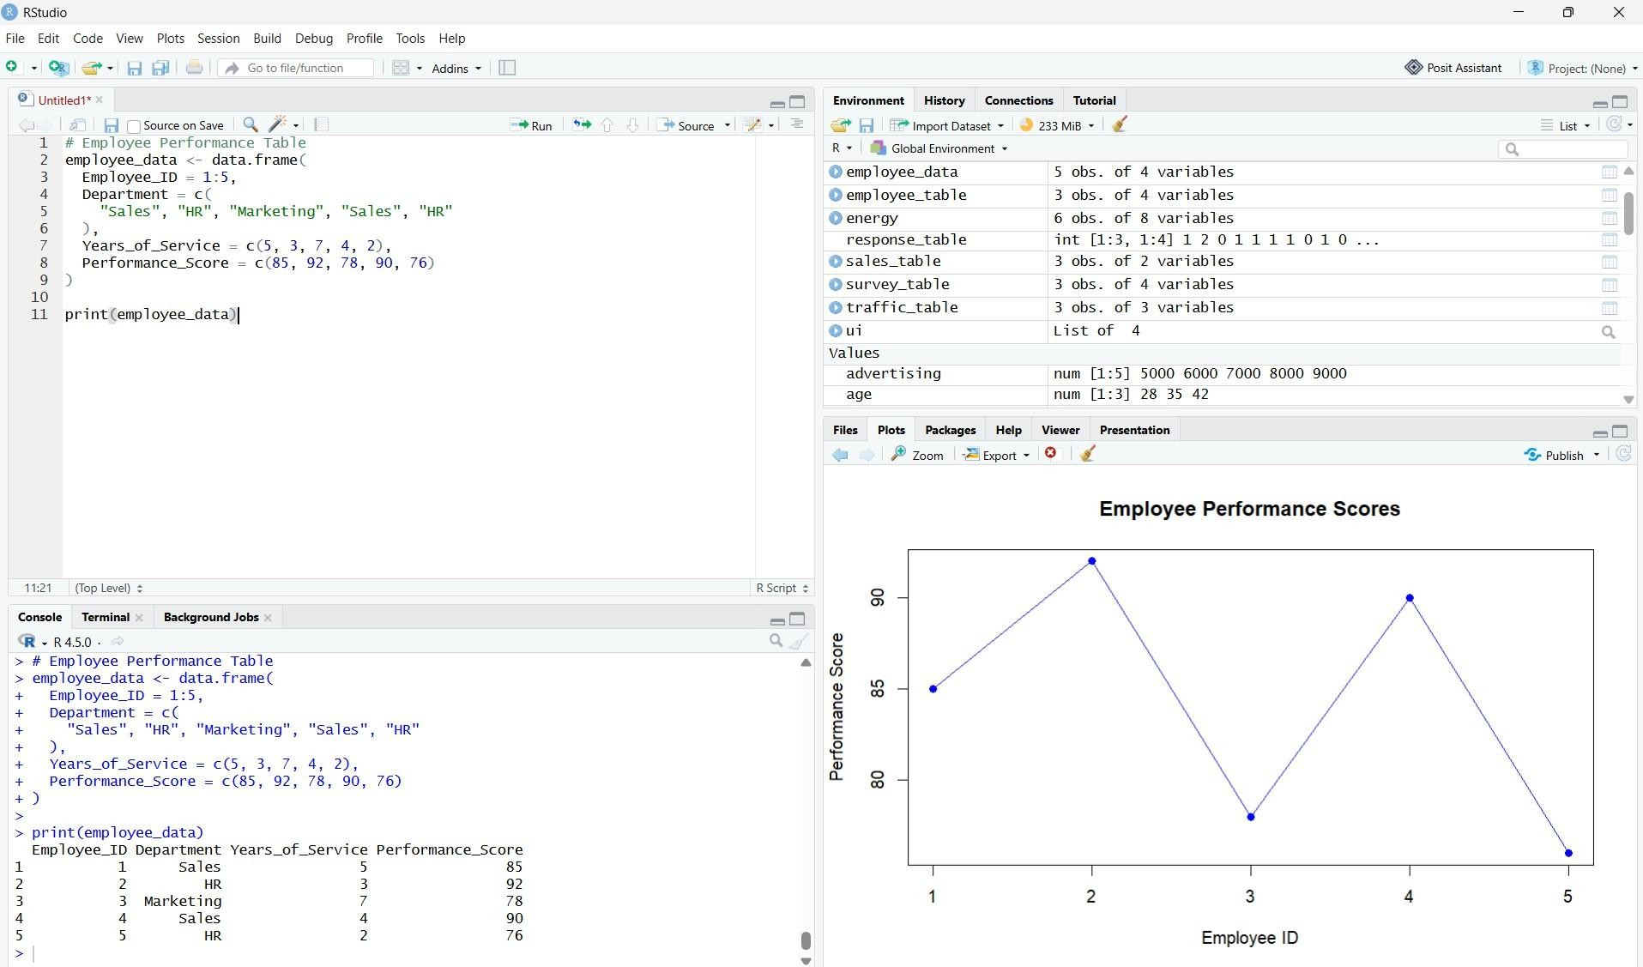
# # Employee Performance Table employee_data <- data.frame(
Employee_ID = 1:5, Department = c(
"Sales", "HR", "Marketing", "Sales", "HR"
),
Years_of_Service = c(5, 3, 7, 4, 2),
Performance_Score = c(85, 92, 78, 90, 76)
)

print(employee_data)in = "Autocorrelation of Monthly Sales"
)}

Observation: The table displays employee IDs, departments, years of service, and performance scores.

Procedure
- Create vectors containing employee IDs, departments, years of service, and performance scores.
- Use table() and barplot() to visualize department distribution.

- Use plot() to create a line chart of employee performance scores.
- Develop a Shiny dashboard combining the department bar chart, service-versus-performance scatter plot, and employee table.
- Create a data frame using data.frame() to display employee details.
- Run the programs in RStudio and examine the results.

Result
Employee performance data was successfully analyzed using a bar chart, line chart, scatter plot, and table. An interactive Shiny dashboard was created to explore department distribution and employee performance.

